Understanding and Supporting Children with Down Syndrome in Schools
A workshop for educators
who want to learn more about successful inclusion of pupils
with Down Syndrome
Webinar: 23rd June 2021 09.00-14.00

Working with children and young people with Down Syndrome can be challenging. Such pupils frequently experience cognitive delay and difficulties with fine motor skills. Thus, their experience of school all too often presents a constant uphill struggle.

This one day workshop will provide practitioners with an overview of how Down Syndrome affects pupils’ experience, and will aim to address the importance of developing conceptual knowledge.

Delegates will also explore how developmental delay impacts upon learning. Particular attention is given to the development of mathematical and literacy concepts, and strategies to facilitate learning will be discussed.

Introduction to Down Syndrome: General traits and learning profile | Developing concepts: How do children with Down Syndrome develop conceptual knowledge? | Down with the Numbers!  Supporting mathematical development in DS | Take a Look – Read a  Book: Supporting language & literacy development in DS
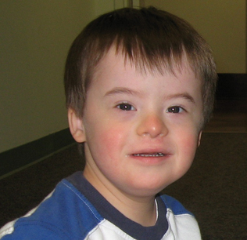 | 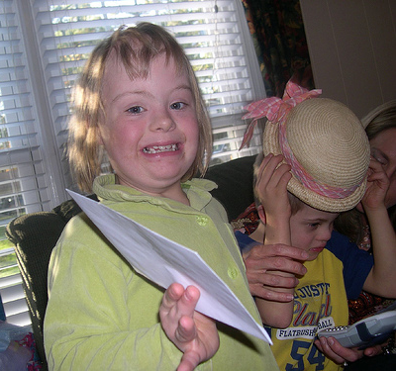

This workshop is appropriate for educators in both mainstream and special settings.
We anticipate high levels of interest in our workshops, so please book early to reserve your place
Jennifer Nock is a Chartered Psychologist and educator with more than 25 years’ experience of working with children and young people, families, educators and those in the caring professions. She has worked in diverse education and special needs settings, including special secondary and primary schools, mainstream primary and nursery schools, FE colleges, and as an SEN advisor. She works with children with a range of learning difficulties, behaviour, emotional and social difficulties, including Down Syndrome, Foetal Alcohol Spectrum Disorder, attachment disorder, AD(H)D and autistic spectrum conditions and is up-to-date with current issues around inclusive practice.

BOOKing form, Understanding and Supporting Down Syndrome
WEBINAR Wednesday 23rd June 2021 Time 09.00-14.00
Please complete in block capitals
NB: WE REALISE THAT STAFFING IS FLUID AND UNPREDICABLE AT THE MOMENT AND THAT CHANGES OCCUR ON A DAILY BASIS. YOU CAN CANCEL YOUR ATTTENDANCE ON THE WEBINAR BUT PLEASE TRY TO GIVE US AS MUCH NOTICE AS POSSIBLE.
Name of ATTENDEE: | School/organisation name and FULL address:
Role IN SCHOOL: | Contact e-mail of attendee:  Mobile for contact on the day if needed:
Date: Wednesday 23rd June 2021, 09.00-14.00
Fee: £90 +VAT (£108) for each Attendee
PAYMent Details:

Please supply the name and contact details of the person who will process payment of invoice:

BACS payments are our preferred method (details will be furnished on the Invoice) but we also accept cheques made payable to ‘Jennifer Nock Training and Consultancy’

