Webinar, Thursday 4th July 2024
09.00 to 12.00

Under Construction: The Teenage Brain

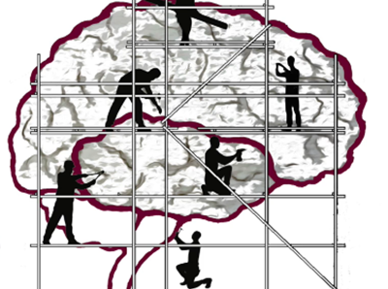

The human brain is not fully developed until between 25 and 30 years of age. Until then, children and young people should be considered a work in progress, particularly in the case of teenagers.
From time immemorial, adults have wrestled with the conundrum that is the adolescent mind: at times growing in maturity before rapidly shifting to volcano-like, emotional outbursts. The first step toward understanding the teenage brain, and how best to support it, is knowing that there are huge differences between the way that the fully mature adult brain and teenage brain work.
On this one-hour workshop we shall explore:
- Teaching teenagers
- The teenage brain: What’s going on?
- Nurturing and developing the teenage brain
- Emotions
- Through a cracked windscreen: Decision-making
- A nurturing environment
BOOKING FORM BELOW

NUMBER OF DELEGATES IS LIMITED AND We anticipate high levels of interest. Please book early to secure your place

Date: Thursday 4th July 2024, 09.00-12.00
Venue: WEBINAR [on ZOOM]
Fee: £80 + VAT per person registered
To reserve your place and request an invoice please contact us at: jennifernock@protonmail.com
and complete and send the booking form below.
NB: It is most important that you include both the contact email details of the attendee AND those of the person in your organisation who processes payment of invoices.
Application form: Under Construction: The Teenage Brain
Thursday 4th JUlY 2024, 09.00-12.00
Please complete in block capitals
NB: YOU CAN CANCEL your ATttendance on the WEBINAR but Please GIVE US FIVE WORKING DAYs’ NOTICE OF CANCELLATION, oTHERWISE YOU BE May BE CHARGED THE WEBINAR FEE
Name of ATTENDEE: | School/organisation name and FULL address:
Role IN SCHOOL: | Contact email address of attendee:
Date: Thursday 4th July 2024, 09.00-12.00
Fee: £80 +VAT (£96) for each Attendee
PAYMent Details:

Please supply the NAME and EMAIL contact details of the person who will process payment of invoice:

BACS payments are our preferred method (details will be furnished on the Invoice) but we are happy to receive cheques made payable to ‘Jennifer Nock Training and Consultancy’

About the trainer
Dr Jennifer Nock is an Educator and Chartered Psychologist, with many years of experience working with children and young people, their families and educators. She is passionate about supporting educators and parents to better understand mental health, behaviour and relationships, and to view children and young people through a developmental lens.
For additional information, and testimonials from our clients please visit our website: http://www.jennifernocktrainingandconsultancy.com/

