Webinar Tuesday 16th March 2021, 10.00-15.00

Pathological Demand Avoidance and School

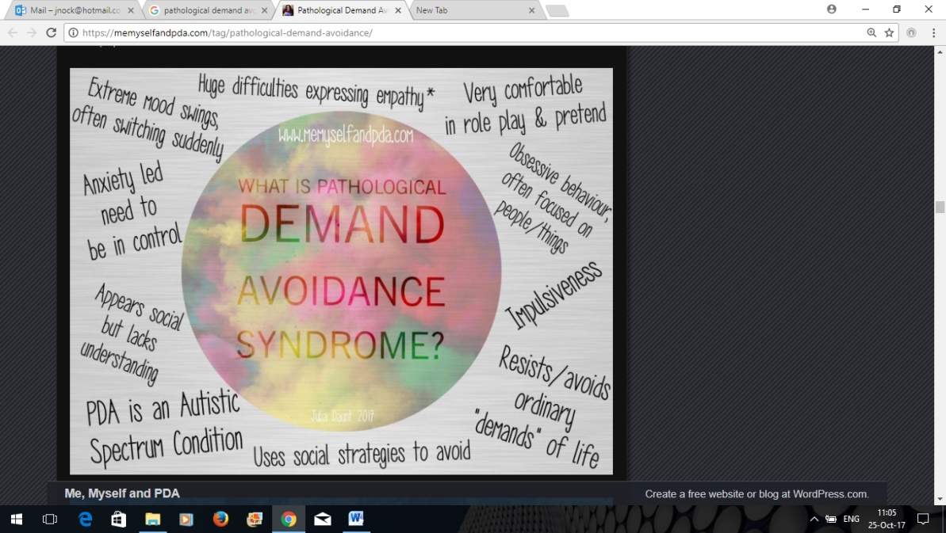

**Pathological Demand Avoidance (PDA)** is increasingly, but not entirely, accepted as a behaviour profile that is seen in some people on the **autistic** spectrum. It is a pervasive developmental disorder, that is, it affects all areas of development. It was first identified in 2003, but is still not currently recognised nor acknowledged in many diagnostic tools for autism. PDA is a complex, challenging and misunderstood condition that is often ignored or not even recognised by many professionals. It is worth noting that strategies which are helpful for learners with autistic spectrum disorders are often not useful in cases of PDA. Those who present with this particular diagnostic profile are driven to avoid everyday demands and expectations to an extreme extent, stemming from an anxiety-based need to be in control.

It can be difficult for educators to understand how best to support pupils with PDA, because traditional management techniques such as structure, routine and rewards that often work for pupils with other autism profiles are generally ineffective. However, it is vital that educators recognise and identify children who may have PDA because early diagnosis, support and intervention is crucial for the best short and long-term outlooks for the child. The correct support and understanding in school also reduces the pressure on teachers and staff.

On this one day workshop, delegates will learn about what PDA is, the core characteristics of PDA and developing strategies and interventions for children and young people with PDA. We shall also explore the interface between PDA and developmental trauma, as children with attachment difficulties show many similarities to those with PDA.

**About the trainer**

Dr Jennifer Nock is an Educator and Chartered Psychologist, with many years of experience working with children and young people, their families and educators. She is passionate about supporting educators and parents to better understand mental health, behaviour and relationships, and to view children and young people through a developmental lens.

For additional information, and testimonials from our clients please visit our website: <http://www.jennifernocktrainingandconsultancy.com/>

**NUMBER OF DELEGATES IS LIMITED TO TWENTY AND We anticipate high levels of interest. Please book early to secure your place**

**Date Tuesday 16th March 2021 10.00-15.00**

**Venue**: **WEBINAR [on ZOOM]**

**Fee: £90 + VAT per person registered**

**To reserve your place and request an invoice please contact us at: jennifernock@protonmail.com**

**and complete and send the booking form below.**

**NB: It is most important that you include both the contact email details of the attendee AND those of the person in your organisation who processes payment of invoices.**

**Application form, PDA WEBINAR Tuesday 16th March 2021**

**Please complete in block capitals**

**NB: YOU CAN CANCEL your ATttendance on the WEBINAR but you must GIVE US FIVE WORKINGS DAYs’ NOTICE OF CANCELLATION, oTHERWISE YOU BE CHARGED THE WEBINAR FEE**

|  |  |
| --- | --- |
| **Name of delegate:** | **School/organisation name and FULL address:** |
| **Role IN SCHOOL:** | **Contact email address of attendee:**  **Mobile for contact on the day if needed:** |
| **Date: Tuesday 16th March 2021, 10.00-15.00**  **Fee: £90 +VAT (£108) for each Attendee** | |
| **PAYMent Details:**  **Please supply the name and contact details of the person who will process payment of invoice:**  **BACS payments are our preferred method (details will be furnished on the Invoice) but we are happy to receive cheques made payable to ‘Jennifer Nock Training and Consultancy’** | |