Webinar
Multi-Layered Trauma
Supporting Children and Young People who are in the Care of Local Authorities in the Covid-19 Era
Wednesday 25th November 2020
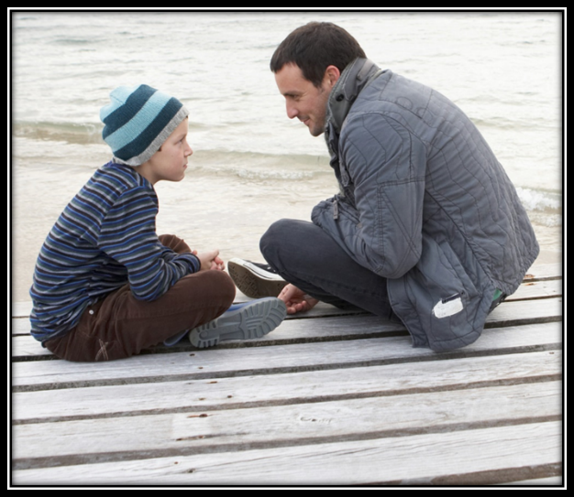

Children and young people who are ‘in care’ are particularly vulnerable at this time of global pandemic. For them, feelings of powerlessness, anxiety, hypervigilance, fear, loss, loneliness and grief are not new; they have been previously experienced, maybe repeatedly. We might describe them as ‘falling down a memory time-hole’, where past memories of being afraid and out of control, resurface and trigger them, exacerbating their current feelings of fear and powerlessness. Many of their memories will be unconscious, yet no less powerful.

It is vitally important for educators, social workers, parents and carers, indeed anyone who works with children who have experienced early trauma and adversity, to be aware of this particularly vulnerable population, and to have the knowledge and skills to support them successfully.
Attendees will explore:
- Understanding the particular needs of LAC and young people
- What is attachment and why does it matter?
- Trauma and attachment
- Assessing and responding to differing levels of need
- Signs and maladaptive coping behaviours to look out for
- Increasing protective factors and ‘safety cues’ throughout the school culture

This new one-day workshop, which links theory to relevant, down-to-earth practice, will be of great benefit to anyone who works with children and young people, and will be of particular relevance to those working in educational settings.

About the trainer
Dr Jennifer Nock is an Educator and Chartered Psychologist, with many years of experience working with children and young people, their families and educators. She is passionate about supporting educators and parents to better understand mental health, behaviour and relationships, and to view children and young people through a developmental lens.
For additional information, and testimonials from our clients please visit our website: http://www.jennifernocktrainingandconsultancy.com/

NUMBER OF ATTENdees IS LIMITED TO TWENTY AND We anticipate high levels of interest. Please book early to secure your place

Date: Wednesday 25th November, 2020 10.00-15.00
Venue: WEBINAR [on ZOOM]
Fee: £90 + VAT per person registered
To reserve your place and request an invoice please contact us at: jennifernock@protonmail.com
and complete and send the booking form below.
NB: It is most important that you include both the contact email details of the attendee AND those of the person in your organisation who processes payment of invoices.
Application form WEBINAR:
Supporting Children and Young People in the Care of Local Authorities in the Covid-19 Era
Wednesday 25th nOVEMBER 2020
Please complete in block capitals
NB: YOU CAN CANCEL your ATttendance on the WEBINAR but you must GIVE US FIVE WORKINGS DAYs’ NOTICE OF CANCELLATION, oTHERWISE YOU BE CHARGED THE WEBINAR FEE

Name of ATTENDEE: | School/organisation name and FULL address:
Role IN SCHOOL: | Contact email address of attendee:  Mobile:
Date: Wednesday 25th November 2020 10.00-15.00
Fee: £90 +VAT (£108) for each Attendee
PAYMent Details:

Please supply the name and contact details of the person who will process payment of invoice:

BACS payments are our preferred method (details will be furnished on the Invoice) but we are happy to receive cheques made payable to ‘Jennifer Nock Training and Consultancy’

