Webinar Tuesday 1st November 09.00-14.00

From Attachment Disorder to Developmental Trauma

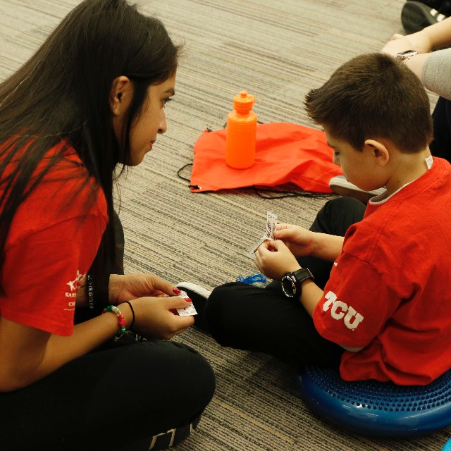

Here is an overview of the course material themes:
- From ‘Attachment Disorder’ to Developmental Trauma
- The Shield of Shame
- Regulation and Co-Regulation
- Strengths-, Resilience- and Hope-Based Practice
- Non-Negotiables for the Classroom

About the trainer
Dr Jennifer Nock is an Educator and Chartered Psychologist, with many years of experience working with children and young people, their families and educators. She is passionate about supporting educators and parents to better understand mental health, behaviour and relationships, and to view children and young people through a developmental lens.
For additional information, and testimonials from our clients please visit our website: http://www.jennifernocktrainingandconsultancy.com/

We anticipate high levels of interest. Please book early to secure your place

Date: Tuesday 1st November 2022, 09.00-14.00
Venue: WEBINAR [on ZOOM]
Fee: £90 + VAT per person registered
To reserve your place and request an invoice please contact us at: jennifernock@protonmail.com
and complete and send the booking form below.
NB: It is most important that you include both the contact email details of the attendee AND those of the person in your organisation who processes payment of invoices.
Application form, ‘Attachment Disorder to Developmental Trauma’ webinar
Tuesday 1st November 2022, 09.00-14.00
Please complete in block capitals
Name of delegate: | School/organisation name and FULL address:
Role IN SCHOOL: | Contact email address of attendee:  Mobile for contact on the day if needed:
Date: Tuesday 1st November 2022, 09.00-14.00
Fee: £90 +VAT (£108) for each Attendee
PAYMent Details:

Please supply the name and contact details of the person who will process payment of invoice:

BACS payments are our preferred method (details will be furnished on the Invoice) but we are happy to receive cheques made payable to ‘Jennifer Nock Training and Consultancy’

