Webinar Wednesday 11th January 2023, 09.00-14.00
Foetal Alcohol Spectrum Disorders

For educators in mainstream and special settings, who want to learn more about working successfully with children and young people who have who have Foetal Alcohol Spectrum Disorders

The exact prevalence of Foetal Alcohol Spectrum Disorders (FASD) in the UK is not known, but research suggests at least 1 in 100 babies are affected. This figure is likely to be higher, as many children are misdiagnosed with AD(H)D or autism, and many are simply labelled as ‘challenging’. It is likely that all schools will have pupils with FASD, so it is important for educators to recognise FASD and to understand how to best work with such pupils, who too often find school a constant uphill struggle as they are ill equipped for the social, emotional and cognitive challenges that they encounter during any given school day. This workshop aims to help educators better recognise FASD in their pupils, and understand the specific problems these pupils experience. It will provide a range of strategies for the development of educational environments that are sensitive to the strengths and difficulties of children and young people with FASD. General challenges in school will be discussed and there will be focus on particular curricular challenges in literacy and numeracy.
What are FASDs? | FASD & School | Numeracy & literacy
 |  | 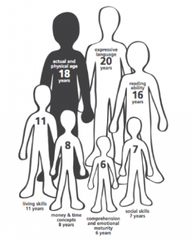
This workshop, which links theory to relevant, down-to-earth practice, will be of great benefit to anyone who works with children in primary, secondary and EYFS settings.

About the trainer
Dr Jennifer Nock is an Educator and Chartered Psychologist, with many years of experience working with children and young people, their families and educators. She is passionate about supporting educators and parents to better understand mental health, behaviour and relationships, and to view children and young people through a developmental lens.
For additional information, and testimonials from our clients please visit our website: http://www.jennifernocktrainingandconsultancy.com/

NUMBER OF ATTENdees IS LIMITED TO TWENTY AND We anticipate high levels of interest. Please book early to secure your place

Date: Wednesday 11th January 202309.00-14.00
Venue: WEBINAR [on ZOOM]
Fee: £90 + VAT per person registered
To reserve your place and request an invoice please contact us at: jennifernock@protonmail.com
and complete and send the booking form below.
NB: It is most important that you include both the contact email details of the attendee AND those of the person in your organisation who processes payment of invoices.
Application form, FASD WEBINAR
Wednesday 11th January 2023, 09.00-14.00
Please complete in block capitals
Name of ATTENDEE: | School/organisation name and FULL address:
Role IN SCHOOL: | Contact email address of attendee:  Mobile:
Date: wednesday 11th january 2023, 09.00-14.00
Fee: £90 +VAT (£108) for each Attendee
PAYMent Details:

Please supply the name and contact details of the person who will process payment of invoice:

BACS payments are our preferred method (details will be furnished on the Invoice) but we are happy to receive cheques made payable to ‘Jennifer Nock Training and Consultancy’

