GETTING CREATIVE WITH SUPERVISION
Training for Leaders and Managers
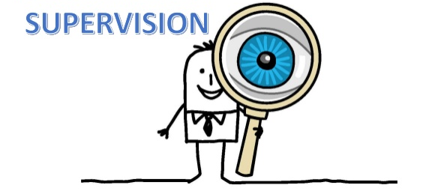
Full day WEBINAR Monday 15th November 09.00-14.00
“The expectation that we can be immersed in suffering and loss daily and not be touched by it is as unrealistic as expecting to be able to walk through water without getting wet.” Remen, 1994
Educators working in many roles in schools, colleges and alternative educational settings regularly support children, young people and their families on a regular basis, often with complex social and psychological, as well as learning-related, issues. In addition to the ‘ordinary’ pressures and challenges, educators are currently facing an additional broad range of challenges in their workplaces with the advent of the Covid-19 pandemic. Thus, the day-to-day work of an educator can be emotionally draining, even detrimental to the educator’s own physical, mental and emotional health. However, unlike other similarly stressful professions, there is a lack of structured, supervisory frameworks to support staff to manage the demands of their role, with the exception of EYFS staff and Emotional Literacy Support Assistants. Leaders and Managers are increasingly recognising that the deficit in providing support to all school staff needs to be addressed as a matter of some urgency, but are unsure of how to do this. Professional supervision does not need to be Clinical in nature, and while some schools do provide this, the cost is often prohibitive with budgets already tightly stretched. Good professional supervision aims to share, reflect on, examine and develop professional practice, thus building resilience in relation to the emotional and psychological impact of the work; it is a framework that facilitates healthy emotional and thinking responses across the whole staff team as well as in the individual; it should be an integral part of practice, not an add-on; while problem solving may be a part of it, it should not be the only focus; and it should never be about ‘performance management’ although it should improve performance. These aims can be met within the framework of a ‘professional conversation’. This workshop will support leaders and managers to develop the skills and strategies necessary to deliver professional supervision, both to individuals and groups. It will aim to take a creative approach, using visual and tactile metaphors to stimulate thought and discussion rather than rely only on the ‘tell me how you’re feeling’ approach. While this is a serious endeavour, the nature of the workshop will be light-hearted and playful, and attendees will be given opportunities to reflect upon their own personal journeys as well as focusing on how they can act as companions to staff on their journeys.
The session will consist of trainer input, reflective activities for attendees (offline), online discussions and Q&A.

NUMBER OF DELEGATES IS LIMITED AND We anticipate high levels of interest. Please book early to secure your place

Date: Monday 15th November 2021, 09.00-14.00
Venue: WEBINAR [on ZOOM]
Fee: £90 + VAT per person registered
To reserve your place and request an invoice please contact us at: jennifernock@protonmail.com
and complete and send the booking form below.
NB: It is most important that you include both the contact email details of the attendee AND those of the person in your organisation who processes payment of invoices.
Application form GETTING CREATIVE WITH SUPERVISION
Monday 15th November 2021, 09.00-14.00
Please complete in block capitals
NB: YOU CAN CANCEL your ATttendance on the WEBINAR but you must GIVE US FIVE WORKING DAYs’ NOTICE OF CANCELLATION, oTHERWISE YOU WILL BE CHARGED THE WEBINAR FEE

Name of ATTENDEE: | School/organisation name and FULL address:
Role IN SCHOOL: | Contact email address of attendee:
Date: Monday 15th November 2021
Time: 09.00-14.00
Fee: £90 +VAT (£108) for each Attendee
PAYMent Details:

Please supply the name and contact details of the person who will process payment of invoice:

BACS payments are our preferred method (details will be furnished on the Invoice) but we are happy to receive cheques made payable to ‘Jennifer Nock Training and Consultancy’

About the trainer
Dr Jennifer Nock is an Educator and Chartered Psychologist, with many years of experience working with children and young people, their families and educators. She is passionate about supporting educators and parents to better understand mental health, behaviour and relationships, and to view children and young people through a developmental lens. For additional information, and testimonials from our clients please visit our website: http://www.jennifernocktrainingandconsultancy.com/

