**York 27th November 2018, 0930-15.00**

**Foetal Alcohol Spectrum Disorders**

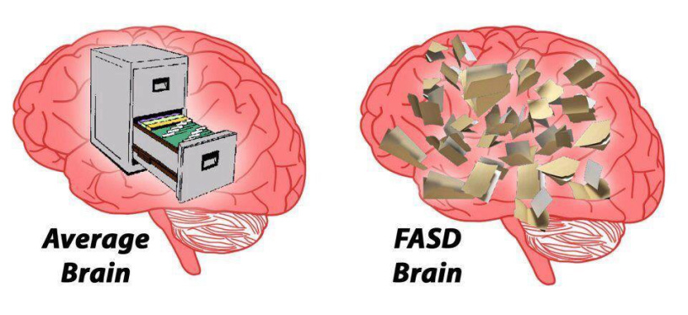

For educators in mainstream and special settings, who want to learn more about working successfully with children and young people who have who have Foetal Alcohol Spectrum Disorders

The exact prevalence of Foetal Alcohol Spectrum Disorders (FASD) in the UK is not known, but research suggests at least 1 in 100 babies are affected. This figure is likely to be higher, as many children are misdiagnosed with AD(H)D or autism, and many are simply labelled as ‘challenging’. It is likely that all schools will have pupils with FASD, so it is important for educators to recognise FASD and to understand how to best work with such pupils, who too often find school a constant uphill struggle as they are ill equipped for the social, emotional and cognitive challenges that they encounter during any given school day. This workshop aims to help educators better recognise FASD in their pupils, and understand the specific problems these pupils experience. It will provide a range of strategies for the development of educational environments that are sensitive to the strengths and difficulties of children and young people with FASD. General challenges in school will be discussed and there will be a focus on particular curricular challenges in literacy and numeracy.

|  |  |  |
| --- | --- | --- |
| **What are FASDs?** | **FASD & School** | **FASD and numeracy and literacy** |
| Facial features: short nose, no indentation between nose and mouth, thin upper lip are dominant features. Image from CDC training module | http://blog-es.kinedu.com/wp-content/uploads/2014/09/iStock_000025336923_Small.jpg | Image result for foetal alcohol spectrum disorders learning profile |

This workshop, which links theory to relevant, down-to-earth practice, will be of great benefit to anyone who works with children in primary, secondary and EYFS settings.

**WE ANTICIPATE HIGH LEVELS OF INTEREST PLEASE BOOK EARLY TO BE SURE OF YOUR RESERVATION. BOOKING INFORMATION BELOW**

**Date:** Tuesday 27thNovember 2018, 0930-15.00

**Venue: Mercure Fairfield Manor Hotel, Shipton Road, York, YO30 1XW**

**Fee:** £140.00+VAT for first delegate, £120.00+VAT for additional delegates.

**To reserve your place, call Jennifer Nock on 07983 482 804/01384 392599, E-mail** [**jnock@hotmail.co.uk**](mailto:jnock@hotmail.co.uk) **or complete and post the booking form below.**

**Please note that this workshop can be tailored to meet the specific needs of your staff and can be delivered as a full- or part-day INSET session in your setting. Contact us for more information.**

**Application form FASD York Tuesday 27th November 2017**

###### Please complete in block capitals

**CANCELLATION POLICY:**

**IF YOU CANCEL YOUR PLACE ON THE WORKSHOP WITH LESS THAN 48 HOURS PRIOR NOTICE BEING GIVEN, THE FULL COURSE FEE WILL BE CHARGED.**

|  |  |
| --- | --- |
| **Name of delegate(s):** | **School/organisation name and address:**  **‘Phone:** |
| **Role(s):** | **Email:** |
| **Date: Tuesday 27th November 2018, 09.30-15.00 (registration from 9am)**  **Venue: Mercure Fairfield Manor Hotel, Shipton Road, York, YO30 1XW**  **Fee: £140.00+VAT for first delegate, £120.00+VAT for additional delegates** | |
| **Do you have any dietary or access requirements? If yes, please give brief details.** | |

**I enclose a cheque for £……………………… made payable to Jennifer Nock**

**TRAINING AND CONSULTANCY**

**Please invoice the school or other organisation** 

**Authorised signature: …………………………………………………………………………..**

Jennifer Nock is a Chartered Psychologist with more than 25 years’ experience of working with children and young people, families, educators and those in the caring professions. She has worked in diverse education and special needs settings, including special secondary and primary schools, mainstream primary and nursery schools, FE colleges, and as an SEN advisor. She works with children with a range of learning, behaviour, emotional and social difficulties, including attachment difficulties, FASD, AD(H)D and autistic spectrum conditions and is up-to-date with current issues around inclusive practice.