Fetal Alcohol Spectrum Disorders
Developmental Vulnerabilities Liverpool 20th February 2018

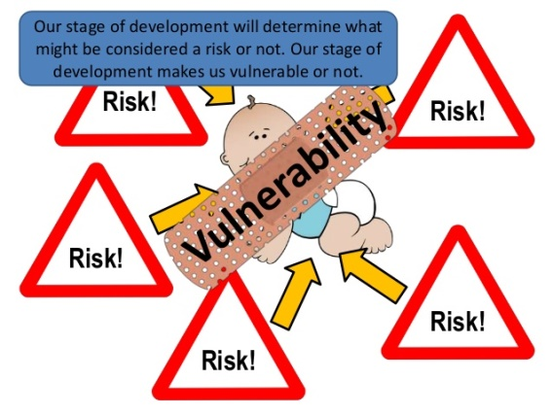

For educators in mainstream and special settings, who want to learn more about working successfully with children and young people who have who have Fetal Alcohol Spectrum Disorders

The exact prevalence of Fetal Alcohol Spectrum Disorders (FASD) in the UK is not known, but research suggests at least 1 in 100 babies are affected. This figure is likely to be higher, as many children are misdiagnosed with AD(H)D or autism, and many are simply labelled as ‘challenging’. It is likely that all schools will have pupils with FASD, so it is important for educators to recognise FASD and to understand how to best work with such pupils, who too often find school a constant uphill struggle as they are ill equipped for the social, emotional and cognitive challenges that they encounter during any given school day. This workshop deals specifically with developmental vulnerabilities in FASD and will provide a range of strategies to support learning and social and emotional development. A working knowledge of what FASD is essential, and preparatory reading will be sent out to all delegates before the workshop. Delegates will explore;

Executive function | Cognitive fatigue | Sensory Overload | Dysmaturity
 |  |  | 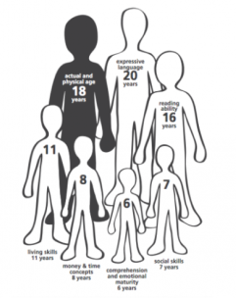

This workshop, which links theory to relevant, down-to-earth practice, will be of great benefit to anyone who works with children in primary, secondary and EYFS settings.

Date: Tuesday 20th February 2018, 9.30 to 3.00.
Venue: Holiday Inn Express Liverpool, Ribblers Lane, Knowsley L34 9HL
Professional Fee: £140.00+VAT for first delegate, £120.00+VAT for each additional delegate.
PARENT/CARER SPECIAL RATE (only for those not funded by schools/colleges etc): £100+VAT

To reserve your place, call Jennifer Nock on 07983 482 804/01384 392599, E-mail: jnock@hotmail.co.uk or complete and post the booking form below.
Please complete a separate form for each delegate.

Please note that this workshop can be tailored to meet the specific needs of your staff and can be delivered as a full- or part-day INSET session in your setting. Contact us for more information.
Application form FASD II Liverpool 20th February 2018
Please complete in block capitals
CANCELLATION POLICY:
IF YOU CANCEL YOUR PLACE ON THE WORKSHOP WITH LESS THAN 48 HOURS PRIOR NOTICE BEING GIVEN, THE FULL COURSE FEE WILL BE CHARGED.
Name of delegate: | School/organisation name and address:  ‘Phone:
Role: | Email:
Date: Tuesday 20th February 09.30-15.00
VEnue: Holiday Inn Express Liverpool, Ribblers Lane, Knowsley L34 9HL
Fee: £140+VAT For first delegaTE; £120+VAT for EACH additional delegate
Do you have any dietary or access requirements? If yes, please give brief details.

I enclose a cheque for £……………………… made payable to Jennifer Nock
TRAINING AND CONSULTANCY

Please invoice the school or other organisation

Please Add the Person/email address to whom the invoice should be senT ………………………………………………………………………………………………………………………………………

Authorised signature: …………………………………………………………………………..

Jennifer Nock is a Chartered Psychologist and educator with more than 25 years’ experience of working with children and young people, families, educators and those in the caring professions. She has worked in diverse education and special needs settings, including special secondary and primary schools, mainstream primary and nursery schools, FE colleges, and as an SEN advisor. She works with children with a range of learning difficulties, behaviour, emotional and social difficulties, including Down Syndrome, Foetal Alcohol Spectrum Disorder, attachment disorder, AD(H)D and autistic spectrum conditions and is up-to-date with current issues around inclusive practice.

