Webinar
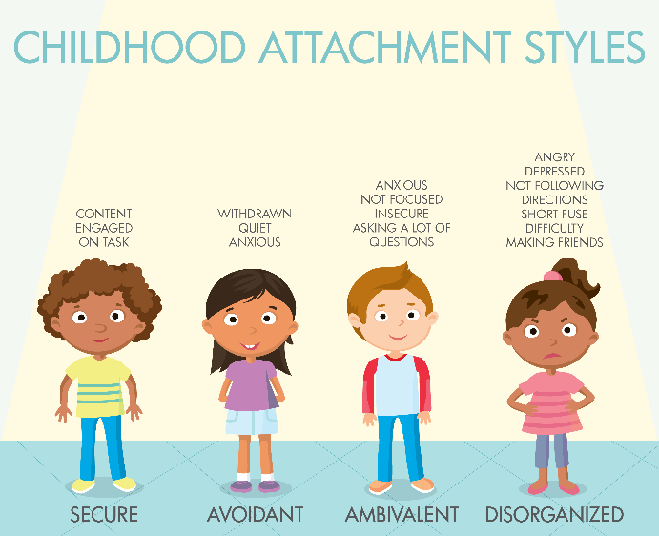
Attachment Styles 2021- Implications for Relationships and Learning in School
Wednesday 16th June 2021

Basic training in attachment and the impact of trauma is essential for educators, and knowledge and understanding of attachment styles provides a context for educators to make sense of and understand the emotional, social and cognitive difficulties that often emerge in children and young people who have attachment problems and insecure attachment styles. It is important to recognise that children can develop four styles of attachment in their family unit:
- Secure attachment is defined by distress when separated from a parent, and joy when reunited. These children feel secure with their family, and while distress may be apparent at separation, they are confident that the carer will return.
- Ambivalent attachment also manifests as distress on separation, but with this style the child does not feel they can depend on their family to support them.
- Avoidant attachment can be observed in children who show no real preference for a carer over a complete stranger. It can be indicative of neglectful or abusive family relationships.
- Disorganised attachment refers to children who have what might seem an unpredictable “love-hate” relationship with their carers. In this group, parents or carers may be a source of both fear and comfort for a child.
Children who are able to develop secure attachments represent only approximately 56 per cent of the population, so knowledge of attachment styles is relevant in evert classroom in every school in every town. When educators know a child's attachment style, then they can use the correct strategies to support them.
This workshop will explore attachment theory and will describe some practical intervention strategies based on research, theory and practice. Building trust and secure relationships in school will be a key focus, reflecting on how schools can be the ‘brick parent’ and how individual educators can provide a secure base for those children and young people who have not been able, for whatever reason, to build secure relationships at home.

About the trainer
Dr Jennifer Nock is an Educator and Chartered Psychologist, with many years of experience working with children and young people, their families and educators. She is passionate about supporting educators and parents to better understand mental health, behaviour and relationships, and to view children and young people through a developmental lens.
For additional information, and testimonials from our clients please visit our website: http://www.jennifernocktrainingandconsultancy.com/

NUMBER OF ATTENdees IS LIMITED TO TWENTY AND We anticipate high levels of interest. Please book early to secure your place

Date: Wednesday 16th June 2021 10.00-15.00
Venue: WEBINAR [on ZOOM]
Fee: £90 + VAT per person registered
To reserve your place and request an invoice please contact us at: jennifernock@protonmail.com
and complete and send the booking form below.
NB: It is most important that you include both the contact email details of the attendee AND those of the person in your organisation who processes payment of invoices.

Application form WEBINAR Attachment Styles 2021
Wednesday 16th June 2021
Please complete in block capitals
NB: WE REALISE THAT STAFFING IS FLUID AND UNPREDICABLE AT THE MOMENT AND THAT CHANGES OCCUR ON A DAILY BASIS. YOU CAN CANCEL YOUR ATTTENDANCE ON THE WEBINAR BUT PLEASE TRY TO GIVE US AS MUCH NOTICE AS POSSIBLE.
Name of ATTENDEE: | School/organisation name and FULL address:
Role IN SCHOOL: | Contact email address of attendee:  Mobile:
Date: Wednesday 16th June 2021, 10.00-15.00
Fee: £90 +VAT (£108) for each Attendee
PAYMent Details:

Please supply the name and contact details of the person who will process payment of invoice:

BACS payments are our preferred method (details will be furnished on the Invoice) but we are happy to receive cheques made payable to ‘Jennifer Nock Training and Consultancy’

